Civil war in Georgia

UNSC Resolution: | 937
Date of adoption: | 21-Jul-1994
Operative paragraph: | 2
Demand number: | 937.0211

David Siroky

Wording of demand
intensify efforts to achieve an early and comprehensive political settlement under the auspices of the United Nations with the assistance of the Russian

List of addressees of the demand
Government of Georgia, Abkhazia

Short-term compliance

Description of the addressee(s)’ conduct
“On 26 Nov. 1994 the Supreme Soviet of Abkhazia adopted a constitution for Abkhazia which declared Abkhazia a “sovereign democratic State...Ardzinba was inaugurated President of the Republic on 6 Dec 1994 (S/1995/10 par 4)”

“On 26 Nov. 1994 the Supreme Soviet of Abkhazia adopted a constitution for Abkhazia which declared Abkhazia a “sovereign democratic State...Ardzinba was inaugurated President of the Republic on 6 Dec 1994 (S/1995/10 par 4)”

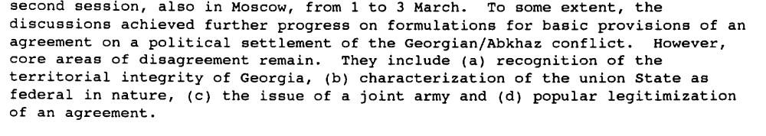s/1995/181

Assessment

Short-term compliance
No or marginal compliance (1) | Medium low compliance (2) | Medium high compliance (3) | Full or almost full compliance (4)

Considerations underlying the assessment

Medium-term compliance

Description of the addressee(s)’ conduct

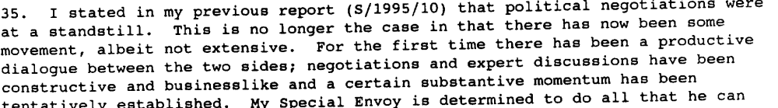s/1995/181

- 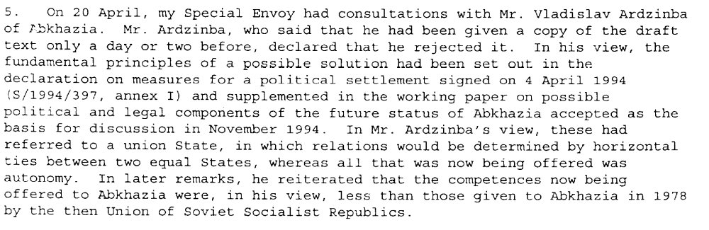s/1995/342

- 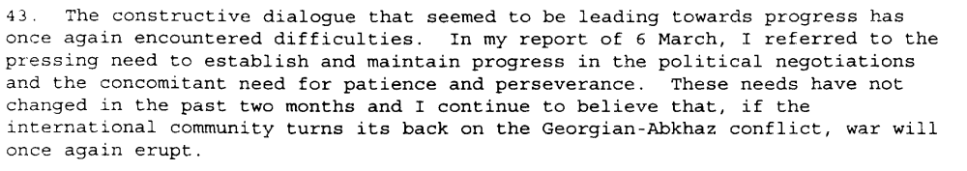s/1995/342

Assessment

Medium-term compliance
No or marginal compliance (1) | Medium low compliance (2) | Medium high compliance (3) | Full or almost full compliance (4)

Considerations underlying the assessment

Depth of demand

Assessment

Level of depth of demand
Low depth of demand (1) | Medium depth of demand (2) | High depth of demand (3)

Considerations underlying the assessment

Level of confidence about coding decisions
Level of confidence about coding decision
Extremely high | High | Moderate

Comments to IPI (if any)

Civil war in Georgia

UNSC Resolution: | 937
Date of adoption: | 21-Jul-1994
Operative paragraph: | 8
Demand number: | 937.0811

David Siroky

Wording of demand
extend full support, necessary protection and freedom of movement to UNOMIG in the performance of its mandate both within the zone of operations of

List of addressees of the demand

Government of Georgia, Abkhazia

Short-term compliance

Description of the addressee(s)’ conduct

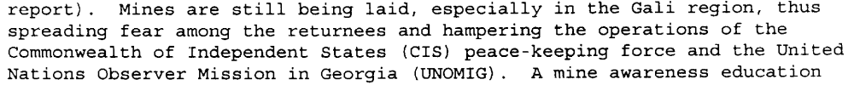s/1994.1160

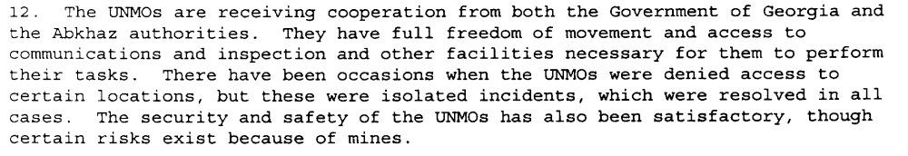s/1994/1160

Assessment

Short-term compliance
No or marginal compliance (1) | Medium low compliance (2) | Medium high compliance (3) | Full or almost full compliance (4)

Considerations underlying the assessment

Medium-term compliance

Description of the addressee(s)’ conduct

“The mission has been receiving cooperation from both the Gov of Georgia and the Abkhaz authorities....the military observers enjoy the freedom of movement necessary to perform their tasks (S/1995/10, par. 20).”

“ ...cooperation with both sides has continued at an acceptable level (S/1995/657, par. 32) ”

“ There have been a number of incidents of armed robberies of UNOMIG personnel on patrol...(S/1995/657, par. 33)”

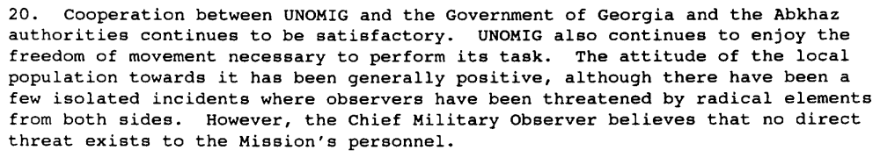s/1995/181

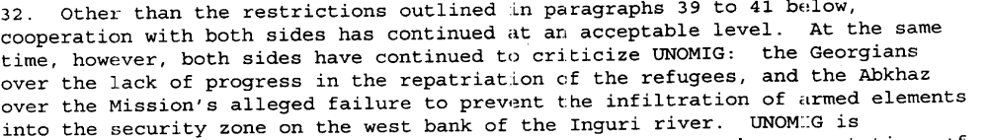s/1995/657

Assessment

Medium-term compliance
No or marginal compliance (1) | Medium low compliance (2) | Medium high compliance (3) | Full or almost full compliance (4)

Considerations underlying the assessment

Depth of demand

Assessment

Level of depth of demand
Low depth of demand (1) | Medium depth of demand (2) | High depth of demand (3)

Considerations underlying the assessment

Level of confidence about coding decisions

Level of confidence about coding decision
Extremely high | High | Moderate

Comments to IPI (if any)

Civil war in Georgia

UNSC Resolution: | 937
Date of adoption: | 21-Jul-1994
Operative paragraph: | 9
Demand number: | 937.0911

David Siroky

Wording of demand
honor the commitments made to support return of all refugees and displaced persons to their homes in secure conditions, in accordance with international law and the Quadripartite Agreement [S/1994/397 Annex II], and accelerate the process as far as possible

List of addressees of the demand

Government of Georgia, Abkhazia

Short-term compliance

Description of the addressee(s)’ conduct

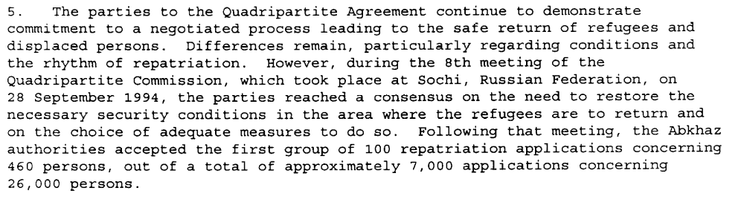s/1994/1160, p. 2

The very slow pace of return of refugees to Abkhazia dominated the agenda. The Abkhaz refused to sign a declaratuon that would have allowed for a speedier return and in larger numbers. It did, however, reduce the review period for consideration of applications from four to two weeks (S/1995/10, p. 1, par. 3)

“..the volume of movement has been very disappointing....since the end of Nov, however, formal repatriation has virtually halted.” (S/1995/10, par. 8 and par. 10)”

“Despite isolated incidents, the Abkhaz have made efforts to ensure the security of returnees...sustained efforts are required to create a secure climate conducive to repatriation (S/1995/10, par. 11 and par. 39)”

Assessment

Short-term compliance
No or marginal compliance (1) | Medium low compliance (2) | Medium high compliance (3) | Full or almost full compliance (4)

Considerations underlying the assessment

Medium-term compliance

Description of the addressee(s)’ conduct

The very slow pace of return of refugees to Abkhazia dominated the agenda. The Abkhaz refused to sign a declaratuon that would have allowed for a speedier return and in larger numbers. It did, however, reduce the review period for consideration of applications from four to two weeks (S/1995/10, p. 1, par. 3)

“..the volume of movement has been very disappointing....since the end of Nov, however, formal repatriation has virtually halted.” (S/1995/10, par. 8 and par. 10)”

“Despite isolated incidents, the Abkhaz have made efforts to ensure the security of returnees...sustained efforts are required to create a secure climate conducive to repatriation (S/1995/10, par. 11 and par. 39)”

“Since my previous report to the SC, there has been no major change in the situation of displaced persons...(S/1995/657, par. 10)”

“The Abkhaz side maintained its previous position of allowing only 200 persons per week to return. This continues to be unacceptable to the other parties (S/1995/657, par. 12)”

“There has been no significant change in the situation of the displaced persons (S/1995/937, par. 10)”

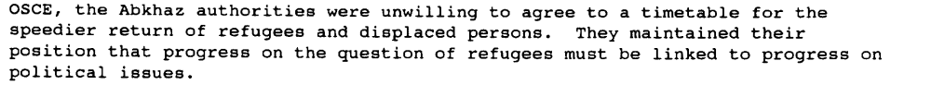s/1995/181

Assessment

Medium-term compliance
No or marginal compliance (1) | Medium low compliance (2) | Medium high compliance (3) | Full or almost full compliance (4)

Considerations underlying the assessment

Depth of demand

Assessment

Level of depth of demand
Low depth of demand (1) | Medium depth of demand (2) | High depth of demand (3)

Considerations underlying the assessment

Level of confidence about coding decisions

Level of confidence about coding decision
Extremely high | High | Moderate

Comments to IPI (if any)

